**Name- Ayushi Gautam**

**Roll No.- 11219**

**Branch- ECE(1st Year)**

**SET-25:**

**Question-1.** WRITE A C PROGRAM TO SUBTRACTION OF TWO DIAMENSIONAL MATRIX.

**PROGRAM CODE:-**

#include <stdio.h>

#include <stdlib.h>

int main()

{

int mat1[10][10],mat2[10][10],sub[10][10];

int i,j,r,c;

printf("Enter the number of row and column of matrices:");

scanf("%d%d",&r,&c);

printf("\nEnter the elements of first matrix\n");

for(int i=0;i<r;i++){

for(int j=0;j<c;j++){

printf("Enter value for element [%d][%d]:",i,j);

scanf("%d",&mat1[i][j]);

}

}

printf("\nEnter the elements of second matrix\n");

for(int i=0;i<r;i++){

for(int j=0;j<c;j++){

printf("Enter value for element [%d][%d]:",i,j);

scanf("%d",&mat2[i][j]);

}

}

printf("\nSubtraction of entered matrices:-\n");

for (i=0;i<r;i++){

for (j=0;j<c;j++){

sub[i][j] = mat1[i][j] - mat2[i][j];

printf("%d\t", sub[i][j]);

}

printf("\n");

}

return 0;

}

**Output:-**

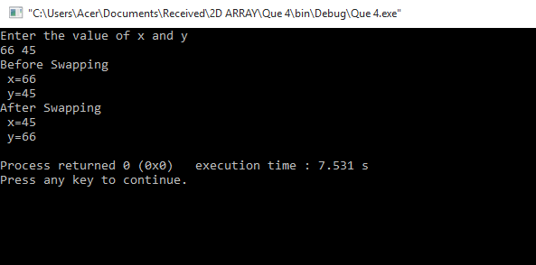

**Question-2.** Write a C-program using Function-swap two numbers using call by Reference.

**Program Code:-**

#include <stdio.h>

#include <stdlib.h>

void swap(int*, int*);

int main()

{

int x, y;

printf("Enter the value of x and y\n");

scanf("%d%d",&x,&y);

printf("Before Swapping\n x=%d\n y=%d\n", x, y);

swap(&x, &y);

printf("After Swapping\n x=%d\n y=%d\n", x, y);

return 0;

}

void swap(int *a, int *b)

{

int temp;

temp = *b;

*b = *a;

*a = temp;

}

**Output:-**

